Battleship Game

Design and implement a battleship game to be played between two players until one comes out as the winner.

Requirements:
● The game will be played in a square area of the sea with NxN grids which will be called a battlefield. “N” should be taken as input in your code.
● The battlefield will be divided in half between both the players. So in a NxN battlefield, NxN/2 grids will belong to PlayerA and the other NxN/2 grids will belong to playerB
● The size and location of each ship will be taken as input. Each ship will be assumed to be of Square shape. Both the players should be assigned equal fleet.
● The location of each ship in the NxN grids has to be taken as input (X, Y). X and Y should be integers. For eg. if a ship “SH1” is at (2, 2) and has the size of 4, its corners will be at (0, 0), (0, 4), (4, 0) and (4,4)
● Ships will remain stationary. No two ships should overlap with each other. However they can touch boundaries with each other.
● Each player will fire one missile towards the enemy field during his turn using the “random coordinate fire” strategy, which means the missile will hit at a random coordinate of the opponent’s field. It might hit or miss the opponent ship. In either case the turn is then transferred to the other player.
○ In case of a hit, the opponent’s ship is destroyed.
○ In case of a miss, nothing happens.
● No two missiles should ever be fired at the same coordinates throughout the course of the game.
● When all the ships of a particular player has been destroyed, he loses the game.

APIs:
Mandatory:
● initGame(N)
This will initialize the game with a battlefield of size NxN. Where the left half of N/2xN will be assigned to PlayerA and the right half will be assigned to PlayerB

● addShip(id, size, x position PlayerA, y position PlayerA, x position PlayerB, y position PlayerB)
This will add a ship of given size at the given coordinates in both the player’s fleet.

● startGame()
This will begin the game, where PlayerA will always take the first turn. The output of each step should be printed clearly in the console.

For eg.
PlayerA’s turn: Missile fired at (2, 4). “Hit”. PlayerB’s ship with id “SH1” destroyed.
PlayerB’s turn: Missile fired at (6, 1). “Miss”

Optional:
● viewBattleField()
This will display the battlefield as a NxN grid and all the ships along with the grids occupied by each ship. PlayerA’s ship with id SH1 will be marked as A-SH1, with id SH2 as A-SH2 and so on. Whereas PlayerB’s ships will be marked as B-SH1, B-SH2 and so on.
Note: It should mark all the grids occupied by a ship and not just the center coordinate.

Guidelines:
● You should store the data in-memory using a language-specific data-structure.
● You can print the output in the console.
● Design your application in a way that a new fire strategy can be implemented and used instead of the default one (random coordinate).
● Implement clear separation between your data layers and service layers.

Expectations:
● Your code should cover all the mandatory functionalities explained above.
● Your code should be executable and clean.
● Your code should be properly refactored, and exceptions should be gracefully handled.
● Appropriate errors should be displayed on console when user input violates the rules of the game.

How will you be evaluated:
● Code Should be working
● Code readability and testability
● Separation Of Concerns
● Abstraction
● Object-Oriented concepts.
● Language proficiency.
● Scalability
● Test Coverage (Bonus Points)

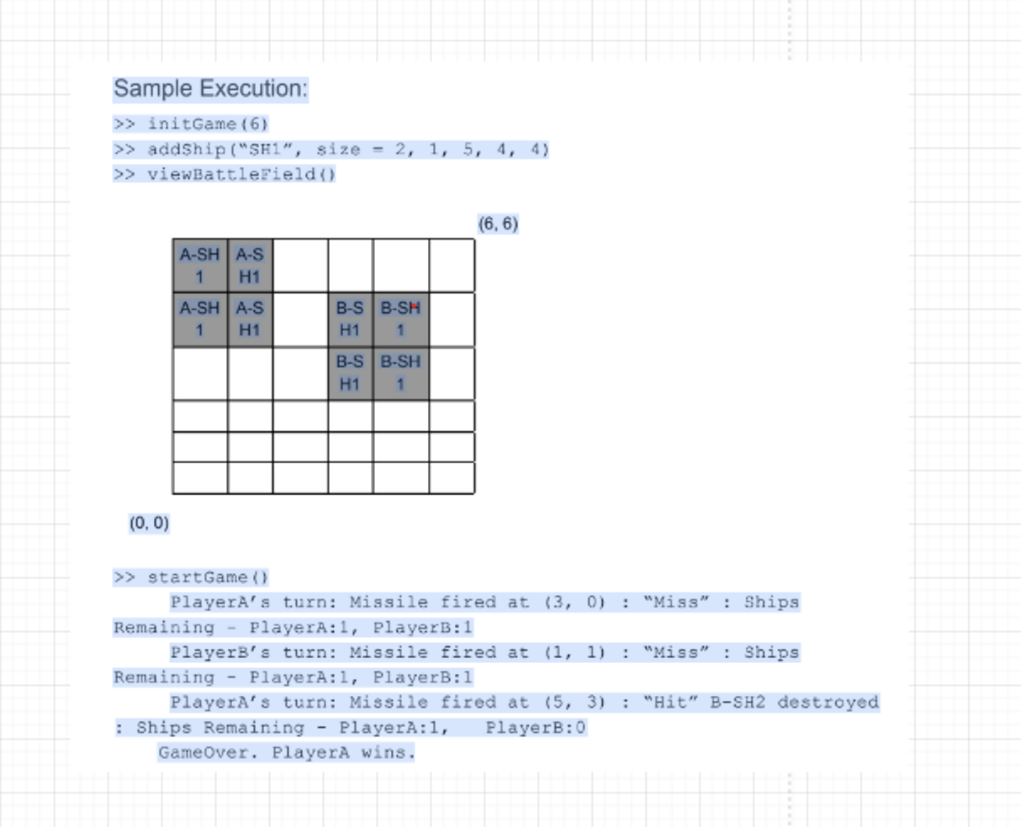

Considering the previous gameplay as the core requirement with few additional requirements Design DB schema:

1. Multiple players could register for the game.
2. Multiple game sessions could be going on.
3. Game's history and all game related metrics/ information needs to be persisted.

>> Design DB schema and major classes structuring with their methods.
>> List down major APIs and their contract.

